# [**John Shiban Tapped As Showrunner For NBC’s ‘Law & Order: Organized Crime’**](https://deadline.com/2023/10/john-shiban-showrunner-nbcs-law-and-order-organized-crime-1235578708/)

By [Denise Petski](https://deadline.com/author/dpetski/)

## [**Denise Petski**](https://deadline.com/author/dpetski/)

*Senior Managing Editor*

#### **More Stories By Denise**

* [George Grobar Named President Of Penske Media Corp.](https://deadline.com/2023/10/george-grobar-president-penske-media-corp-1235578385/)
* [‘A Black Lady Sketch Show’ Star Skye Townsend Signs With ColorCreative](https://deadline.com/2023/10/skye-townsend-signs-colorcreative-a-black-lady-sketch-show-1235577007/)
* [‘Blue Bayou’ Filmmaker Justin Chon Inks With WME & Blue Marble Management](https://deadline.com/2023/10/justin-chon-wme-blue-marble-management-1235577518/)

[**VIEW ALL**](https://deadline.com/author/dpetski/)

October 19, 2023 4:00pm

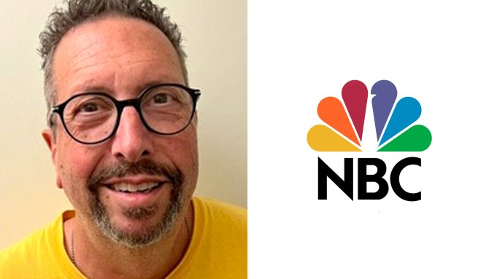

**John Shiban**Courtesy of John Shiban

*Ozark* vet [John Shiban](https://deadline.com/tag/john-shiban/) has been named executive producer and showrunner for [NBC](https://deadline.com/tag/nbc/)‘s *Law & Order: Organized Crime.* Shiban fills the [last remaining open showrunner spot](https://deadline.com/2023/10/law-order-svu-writers-room-chicago-fire-fbi-international-showrunner-wolf-entertainment-1235564367/) for [Wolf Entertainment](https://deadline.com/tag/wolf-entertainment/) & Universal Television’s drama series following the end of the writers strike. *Law & Order: Organized* Crime is set to air in midseason.

Shiban replaces Sean Jablonski, who [stepped down](https://deadline.com/2023/03/law-amp-order-organized-crime-sean-jablonski-exits-showrunner-svus-david-graziano-oversee-remainder-season-3-1235285596/) as showrunner in March, the fourth showrunner to exit the NBC police procedural in a little over a year. At the time, *SVU*’s David Graziano stepped in to oversee the remaining three episodes of Season 3.

### Related Stories



### [Wolf Entertainment Opens 8 Writers Rooms, Sets ‘Chicago Fire’ & ‘FBI: International’ Showrunners](https://deadline.com/2023/10/law-order-svu-writers-room-chicago-fire-fbi-international-showrunner-wolf-entertainment-1235564367/)

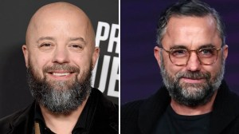

### [‘Law & Order: Organized Crime’: Sean Jablonski Exits As Showrunner; ‘SVU’s David Graziano To Oversee Remainder Of Season 3](https://deadline.com/2023/03/law-amp-order-organized-crime-sean-jablonski-exits-showrunner-svus-david-graziano-oversee-remainder-season-3-1235285596/)

Writers rooms began opening earlier this month, shortly after the WGA reached a deal, for Wolf Entertainment and Universal TV’s three *Chicago* dramas for NBC, three[*FBI*](https://deadline.com/tag/fbi/)dramas for CBS as well as NBC’s *Law & Order* and *Law & Order: SVU.*

Starring [Christopher Meloni](https://deadline.com/tag/christopher-meloni/), *Law & Order: Organized Crime* is executive produced by Dick Wolf, John Shiban, Paul Cabbad, Meloni, Arthur W. Forney and Peter Jankowski.

The series is produced by Universal Television, a division of Universal Studio Group, in association with Wolf Entertainment.

This is veteran showrunner Shiban’s first time as showrunner/EP for a series in the Wolf universe.

Shiban spent the last three seasons as an executive producer on the Emmy-, Golden Globe- and Critics Choice-nominated Netflix series *Ozark,* starring Jason Bateman and Laura Linney. He was nominated for both an Emmy and a WGA Award for writing the episode “Boss Fight.”

Previously, Shiban was under an overall deal at Sony Television while serving as showrunner and executive producer of the Hulu series *Shut Eye.*

Shiban began his career as a staff writer on *The X-Files.* During his stint on the Fox series, he wrote or co-wrote over 20 episodes, earning an Emmy nomination for writing, and served as executive producer by the end of its nine-year run. As a producer, Shiban also received a Golden Globe Award and an Emmy nomination for Outstanding Dramatic Series for his work on *X-Files.*

Shiban joined AMC’s *Breaking Bad* as a consulting producer in Season 2. He penned several episodes of the acclaimed series, received a WGA Award nomination for the episode “Phoenix”and wrote and directed the Season 3 penultimate episode “Sunset.” His other credits include *Da Vinci’s Demons, Hell on Wheels, Vampire Diaries* and the long-running hit *Supernatural.*

His director credits include *Better Call Saul, NOS4A2* and *Shut Eye.*

Shiban is repped by CAA, Artists First and Hansen Jacobson.

*Nellie Andreeva contributed to this report.*